PVA Advocacy Toolkit

Welcome to PVA's Advocacy Toolkit! Whether this is your first time advocating or you already have experience, I want this toolkit to empower you with information to create meaningful change. Advocacy can have a huge impact on how rules and legislation are shaped, both at the local and federal levels. As a PVA member and professional, I have found that the most impactful way to make change is by sharing our stories to help shape the future. Whether you are meeting with lawmakers about legislation or speaking with a member of your local community, conversations matter. Every step a person takes, whether it's sending a quick letter to your congressional office or chatting with your neighbor, moves us in the right direction. You are uniquely qualified to be a grassroots advocate through your personal experiences.

To help you navigate this process, we have created a PVA Advocacy Toolkit, which contains:

- Getting Started with PVAction Force;
- Three Tips to Help You Tell Your Story;
- FAQs;
- Sample Social Media Posts;
- Compelling Social Media Graphics; and
- Additional Resources and Tools.
We need your voice, your passion, and your tenacity to help guide legislation. You make grassroots advocacy effective because it comes from a place of authenticity by someone who cares enough to try to make a difference.

We have an action-packed road ahead of us, and I look forward to working beside all of you along the way!

Warmly,

Lisa Elijah
Grassroots Advocacy Manager

Getting Started with PVAction Force

What is PVAction Force?
PVAction Force is a national grassroots advocacy network led by PVA that takes action on vital issues affecting Veterans with spinal cord injuries and diseases, like MS and ALS, as well as all people with disabilities. Free and open to all Americans, the group participates in petitions, receives important legislative alerts, and more!

Join PVAction Force today and help PVA "Make an Impact Today and Every Day." By signing up, you'll receive:
• Timely alerts on key legislation,
• Easy ways to contact lawmakers,
• Opportunities to attend briefings or events, and
• Campaign toolkits (like this one) to amplify your messaging.
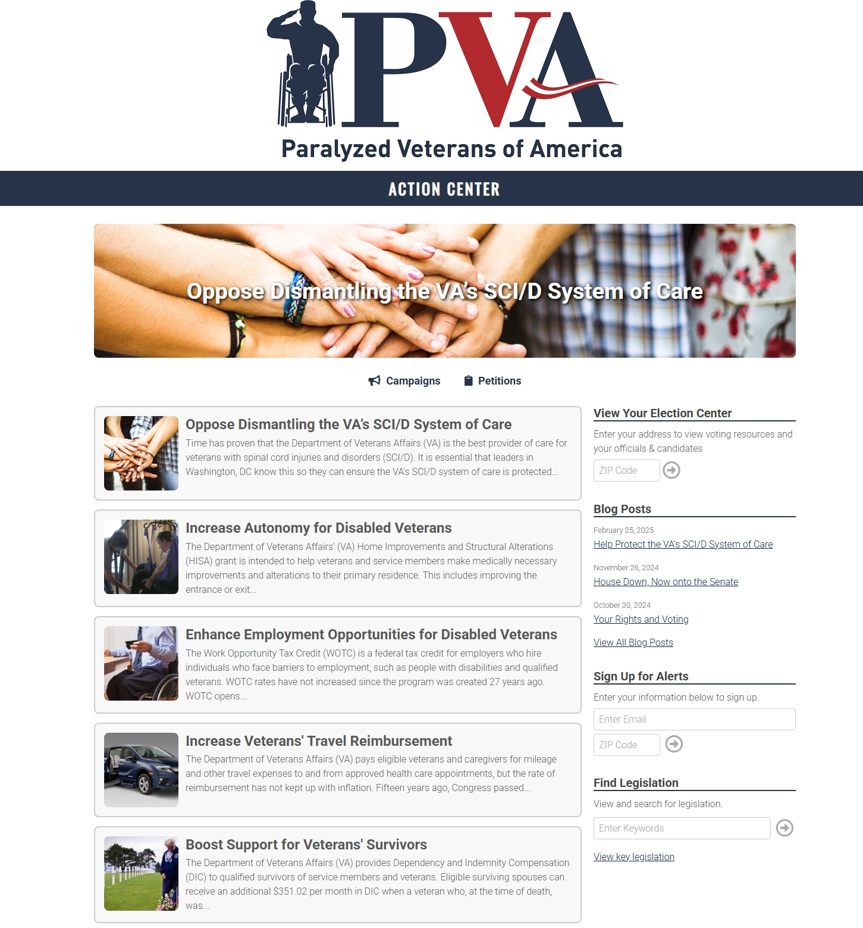
Three Tips to Help You Tell Your Story
PVA's expert storyteller Lynne Switzer shares three tips to consider before sharing your stories with members of Congress, with your family and friends on social media, and wherever else you decide to share your experiences.
- Understand PVA's 2025 Policy Priorities so you can effectively communicate our issues, your experiences, and our desired action.
- Improve your familiarity with relevant legislation. Have key facts and statistics available, so you can advocate strategically, establish your credibility, and share exactly how the audience can make a difference.
- Emphasize the relevant details and broader benefits of PVA's policy priorities. This can lead to more meaningful conversations and prepares you to answer questions in a clear, concise manner.
- Be well-prepared. This will increase your confidence, which can improve your overall effectiveness as an advocate.

- Build a personal connection with your audience.
  - Find areas of commonality by researching your representative or target audience ahead of your meeting. This can help build long-term, meaningful relationships with your members of Congress or target audience.
  - Humanize the issue so others can identify with your experience. For example, reminding your representative or senator that a majority of us will be impacted by a disability at some point in our lives - whether personally, a loved one, or a good friend - can compel them to consider ways to support PVA's policy priorities and spark a sense of urgency to act more quickly.
  - Share a personal story or other real-life tangible example of how legislation affects individuals and relevant communities. Help your representative vividly "see" the legislation's impact and how the decisions they make could be beneficial or harmful.

- Answer the "why" before your audience even asks.
  - Explain why taking meaningful action matters upfront. This helps your target audience grasp the significance and sense of urgency to act.
  - Get ahead of any opposition or pushback. Sharing why PVA's policy priorities are lifesaving and necessary and how your senator/representative can act to protect our nation's Veterans can clear up any misconceptions and potential objections, moving the needle on our policy priorities.
  - Communicate with transparency. Be honest and open, which helps foster trust between advocates and lawmakers, and can help provide your representative with stronger arguments and examples that can be used in future debates and discussions.

FAQs for First-Time Advocates
I know advocacy can feel intimidating if you've never done it before. You might wonder if you're saying the right thing, doing enough, or even if your voice will make a difference. The good news is if you care, you're qualified. Below are a few Frequently Asked Questions to help you get started.
Q: What is grassroots advocacy, anyway?
A: It's change that starts with you. Grassroots advocacy means real, everyday people speaking up about real issues. It's calling your elected officials, sharing your story, writing letters, and spreading awareness. The strength of our movement comes from people like you!
Q: I've never contacted my lawmakers before. Is it hard?
A: Not at all! PVA makes it easy. With just a few clicks, you can send a pre-drafted message through PVAction Force. You can also personalize it to share why the issue matters to you. Congressional offices do read and track these messages—especially when they come from constituents.
Q: What if I want to advocate but not share my personal story?
A: That's okay! While personal stories are powerful, there are many other ways to be an advocate—amplify others' voices, share facts, volunteer behind the scenes, or take action anonymously.
Q: What types of policies do PVAction Force members and PVA staff advocate for?
A: We focus on the issues that matter most to paralyzed Veterans and their families, including:
- Adaptive housing and vehicle grants;
- Access to quality specialized VA healthcare;
- Civil rights and disability protections;
- Employment and independent living resources;
- Support for caregivers;
- And more!
You'll always know what you're supporting and why.
Q: Who can I involve?
A: Advocacy is for everyone of all ages! We encourage you to involve family, school groups, and civic organizations. It's a powerful way to model leadership and service.
Q: How often do you send advocacy alerts?
A: We're strategic, not spammy. You'll hear from us when there's a real opportunity to make an impact, and we'll always provide clear context and simple steps.
Q: Who can I contact if I have questions or need help getting started?
A: PVA is here for you! Whether you need tech help, storytelling support, or want to explore further involvement, contact me at LisaE@PVA.org or (202) 416-7602.
Sample Social Media Posts and Graphics

When you speak up online, people pay attention. Social media is one of the fastest and most effective ways to raise awareness and amplify the voices of Veterans with spinal cord injuries and diseases, like MS and ALS, as well as their families and caregivers. Whether you have 100 followers or 1,000, your post can inspire someone to care, take action, or even join our efforts. You don't need to post every day or have the perfect graphic. Just be real, passionate, and clear about the impact people can make if they get involved.

Use your platform to:
- Share calls to action, especially when Congress is voting on key issues;
- Highlight the real-world impact of policies that impact disabled Veterans;
- Celebrate advocacy wins and thank lawmakers, friends, and family who support our community; and
- Invite friends, family, and other followers to join PVAction Force or send a letter.
Don't worry about crafting the perfect message – we've got some ready-to-go examples for you below. To save images and graphics directly from this toolkit, hover your mouse over the image, right-click, and select "Save as Picture." You can also download the materials by clicking the “DOWNLOAD” text.

However, we highly recommend sharing your own photos when you can. Posts with personal images often get more engagement, and we’ve included a few ideas below to help you think through what to share. Just be sure to tag us so we can help amplify your message!
Handles | Hashtags | URL
Facebook: @ParalyzedVeterans  Instagram: @pva1946  LinkedIn: @Paralyzed Veterans of America  X (formerly Twitter): @PVA1946 | #PushingAccessForward#PVActionForce  - #Veterans  - #BarriersStillExist | - https://pva.org/research-resources/legislative-priorities/ (PVA Policy Priorities page)  - https://pva.org/research-resources/pvaction-force/ (PVAction Force)

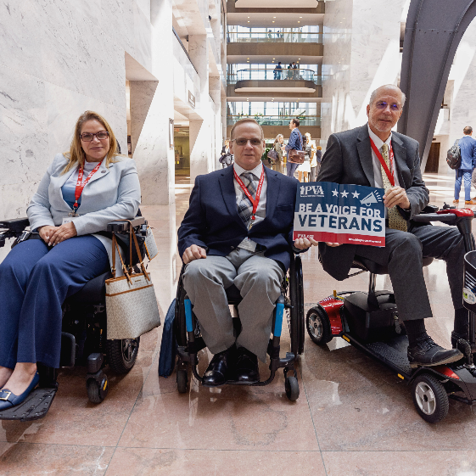  DOWNLOAD IMAGE  ALT: Three Veterans with their power scooters, manual wheelchairs, and mobility scooters pose in the Hart Senate Office Building after visiting their representatives. The two Veterans on the right hold a PVA sign that reads, “Be a Voice for Veterans.”  PERSONAL PHOTO IDEAS  - Images of you on the Hill or visiting lawmakers  - Posing with friends or caregivers who support your advocacy  - A throwback photo of when you first got involved with PVA | Change starts with us! 🫡  That’s why I joined #PVActionForce—to fight for paralyzed and disabled #Veterans, like me, and you should too.  Join us in #PushingAccessForward because no one should have to fight alone for the rights and benefits they earned: https://www.votervoice.net/PVA/Home.
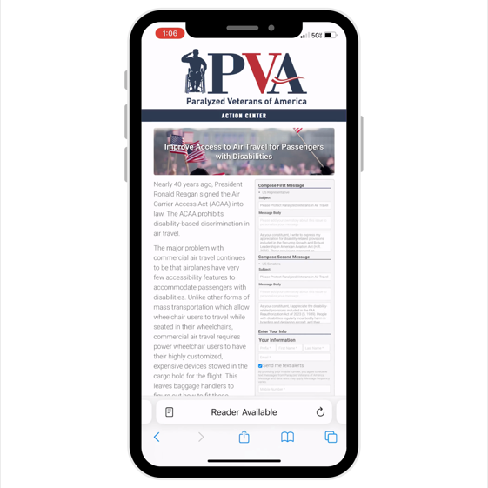  DOWNLOAD VIDEO  PERSONAL PHOTO IDEAS  - A screenshot or photo of you submitting a letter online  - A video or selfie calling on friends to take action  - A photo of your computer screen with the VoterVoice site open  - You wearing PVA gear while doing advocacy from home | #Veterans like me are fighting for change, and WE NEED YOUR HELP! 💪😤  It takes <1 MINUTE to send your members of Congress a #PVActionForce letter asking them to support #Veterans, our families, and #Caregivers.  We’ve got pre-written ones—just hit send: https://www.votervoice.net/PVA/Home.
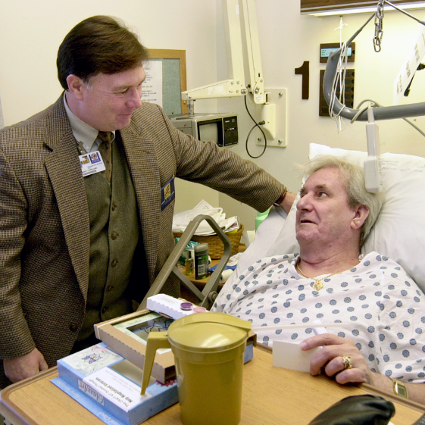DOWNLOAD IMAGE  ALT: A PVA National Service Officer stands beside a hospital bed, engaging with a Veteran in a hospital gown. The NSO rests a hand on the bed rail as the Veteran, holding a card, looks up at him. Medical supplies and personal items are on the bedside table.  PERSONAL PHOTO IDEAS  - A photo of you in the hospital or rehab facility  - A quiet moment of recovery, maybe with family or PVA staff  - A side-by-side or “then and now” comparison  - A meaningful object or memento from that time (like your hospital bracelet) | After my injury/diagnosis, I didn’t know where to turn 😔  Then PVA met me at my bedside and gave me more than resources—they gave me hope and a reason to advocate!  Join #PVActionForce to help in #PushingAccessForward for #Veterans and those with disabilities: https://www.votervoice.net/PVA/Home.

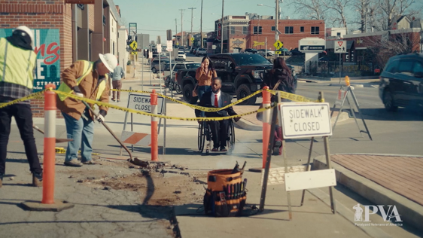  DOWNLOAD VIDEO  PERSONAL PHOTO IDEAS  - A shot of you facing a barrier (e.g., no curb cuts, blocked ramps)  - A day-in-the-life photo or video that shows how you navigate your town  - Photos showing wheelchair or mobility device wear and tear from poor accessibility | Every day, people like me face accessibility barriers most people never even see 🚧🧑‍🦽  That's why I’m fighting for the freedoms of paralyzed and disabled #Veterans—and we need YOU!  Sign up for our #PVActionForce to stay in the loop on our latest efforts: https://www.votervoice.net/PVA/Home.

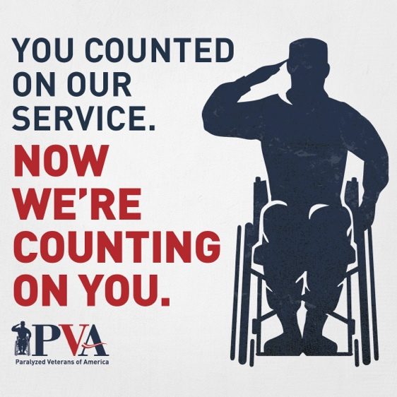  DOWNLOAD IMAGE  ALT: A graphic that reads, "You counted on our service. Now we're counting on you." The background features a dark blue silhouette of a person in a wheelchair saluting, which is part of the Paralyzed Veterans of America logo shown at the bottom.  PERSONAL PHOTO IDEAS  - A shot of you at a government building or talking with lawmakers  - A photo showing the positive or negative impact this bill could have  - Photos of your caregiving setup or the people who support you to highlight how policies affect more than just the Veteran  - A handwritten note or sign that says what this bill would mean to you | A new bill in Congress could actually change my life—and so many others—for the better 📢  But it won’t happen unless we ALL speak up!  Tell your reps to support paralyzed and disabled #Veterans by sending a pre-written #PVActionForce letter TODAY: https://www.votervoice.net/PVA/Home.

DIRECTIONS ON HOW TO FIND/TAG CONGRESSIONAL REPRESENTATIVES ON SOCIAL MEDIA
- Visit Congress.gov/members/find-your-member and enter your address.
- Click on your representatives' blue, underlined name to open their profile.
- In the profile, click on the blue, underlined text next to "Website" to open their website.
- Look for Facebook, Instagram, Twitter (X), etc. icons in the website header or footer.
- Click on the preferred social media icon to open the representative's profile.
- Copy the text after the "/" in the URL or search bar, as this is the representative's handle.
  - Note: sometimes, the handle is the profile name.
- Go to your chosen social media platform, create a post, and type "@" followed by the handle to tag your representatives in the text of the post.
- For tagging in a post image
  - Facebook: Click "Edit" and then "Tag photo," paste the handle, and click the dialog box that appears below the text.
  - Instagram: Click anywhere on the image, paste the handle, and click the dialog box that appears below the text.
  - Twitter (X): Click "Tag people" under the image, paste the handle in the "Search people" box, and click the dialog box that appears below the text.
If no social media links are on their website, search for your representative's name on the platform and follow steps 6-8.

Additional Resources and Tools

Thank you for stepping into advocacy with PVA! Whether you are brand new to advocating or ready to increase your impact, the tools you need are within reach – and so is our support. Below are useful links, templates, and guides to keep your momentum going.

Advocacy Scripts (email and phone)
Lisa – I recommend drafting brief scripts for members to utilize here.

2025 PVA Policy Priorities

Policy One-Pagers
PVA Videos

