PVA Postal Matches – 2022/23
OFFICIAL MATCH PROGRAM

PURPOSE November 2022

This year we will once again run the PVA Postal Matches. These matches allow competitors to shoot at their home ranges, then email targets for scoring. Matches will be held between November 2022 – Mar 2023, with targets being due the last day of each month.

One exception from the NVWGs will be that we will only have categories for Classification (SH-1, SH-2 & SH-3/VI), and not Gender. Those with access to electronic scoring systems, such as Sius and Megalinks will also be able to participate.

All competitors are responsible for securing their own equipment (Rifle and pellets, targets; and jacket, sling and glove, if used). Targets can be mailed out to participating Chapters upon request.

Each target will be signed by the shooter, and a designated witness. A photo of the equipment and range being used for this match is also required. We are entrusting all participants to maintain the integrity in running these matches at home using the guidelines provided below.

CLASSIFICATION

Classifications for those who previously competed at the air gun event during the NVWGs should be used. The National Office would assist in classifying any Novice shooter who had not been previously classified.

For those without a classification at the NWVGs, the following guidance will be used:
SH-1 –
- this applies to shooters who have the ability to safely hold, and fire the rifle with both hands.

- shooters are permitted to place both elbows on the table for support.

SH-2 –
- this category applies for shooters who have limited ability to safely hold the rifle with both hands.

- SH-2 shooters are permitted use of an approved spring stand¹ for support. When using a spring stand, one elbow is permitted to be on the table for support. The second hand may be placed on the rifle, but behind the spring stand and may not make contact with the stand.

- shooters are also permitted to have a loader. The loader may only take directions from the shooter as far as adjusting the sights, and are not permitted to provide coaching assistance/recommendations.

SH-3/VI
- SH-3/VI is for vision impaired shooters using the ECOAIMS targeting system. Please reach out if you would like more information on this Classification.

- An International Shooting Sport Federation (ISSF), or Shooting Para Sport (formerly IPC) approved jacket, sling and glove are permitted for all Classifications)

MATCH PROGRAM

Each match will begin with a 15-minute sighter and preparation time. During this time shooters may adjust their position and shoot unlimited sighters.

The match will consist of 60 shots in 75 minutes in the prone position for all Classifications.

This match will also be open to those who have access to an electronic scoring system such as Sius, or Megalinks. Those shooting on electronic targets in the SH-1 classification will have 50 minutes for 60 shots, SH-2 classification will have 60 minutes for 60 shots and SH-3/VI will have 75 minutes.

A clear photograph, or scanned copy, of each paper target must be submitted by the last day of each month. These targets will then be scored, with results being posted. These scores will then be used to determine the winners in each Classification

Those with electronic targets can submit a print out of the 60-shot match, or a photograph of the summary screen after taking the final shot.

Each month will be a different match with targets due by the following dates for scores to be considered for that match:

30 November 2022
31 December 2022
31 January 2023
28 February 2023
31 March 2023
30 April 2023
31 May 2023

A photograph, or scanned copy shall be emailed from each participant, or Chapter to John Arbino, johnar@pva.org at the completion of each match.

GENERAL INFORMATION

The center two bulls of the paper target are to be used as sighter targets only, and will not counted towards the final score. Shooters may return to shoot at the sighter targets when switching target sheets, but will not be granted additional time.

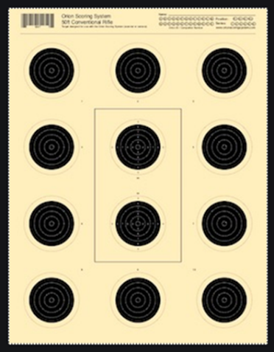
Sighter Targets – these are to be used during the 15 minute sighter and preparation time at the beginning of the match. They may be also be shot when the targets are changed, but shooters will not be given additional time.
Scored targets – the 10 targets surrounding the sighter targets are used for scoring.

It is the shooters responsibility to ensure they engage each target. In the event they have two holes in a target, then they should skip the next target. The extra shot will be scored for the blank target.

If there is an extra shot, without a blank target, then the higher score of the target with multiple shots will be removed. Only the lower score of any target with multiple shots will be scored.

Range Requirements. When building a range at home, several factors should be taken into consideration.
- The length of your range should be 10 meters, or 32.8 feet. This is the distance from the front of the target to the leading edge of your shooting platform.
  - If you are shooting off of a table, then this would be the front leg of the table.

  - If you are shooting off of a table mounted to a wheelchair, then this would be your front caster.

  - It is easiest to measure 10 meters from the target and place a piece of tape to mark your firing line. Just ensure that nothing you are using for support makes physical contact with the ground beyond your firing line.

- The height of the target on a single bull target 1.4 meters, or 4.6 feet, to the center of the bull. We will use the center of the 10-bull paper target for this match.

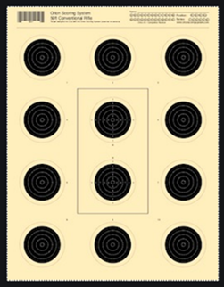
1.4 meters, or 4.6 feet from the ground

- If you do not already have one, you may to purchase, or build a target box to hold your target and catch pellets.
  - One you could purchase is, https://www.pyramydair.com/s/a/Air_Venturi_A_G_E_Quiet_Pellet_Trap_Incl_Ballistic_Putty/1018

  - These target boxes can also be built using ½ inch medium density fiber, or plywood. Just ensure whatever the target is attached to will allow for the pellet to penetrate. You could use a piece of cardboard as the face of your box, with a towel to stop the pellets. This is to help prevent the possibility of a ricochet, and keep the pellets inside the box.

Target Scoring
- Ensure each target has your first and last name at the top of the target, along with the date. A second person who witnessed the targets being shot should also print and sign their name on the front of the target.

- Clear photographs, or scanned copies of each target should be emailed to John Arbino, johnar@pva.org for scoring.

Safety Considerations
The three fundamentals of gun safety should apply every time you handle any firearm:
- Always keep the rifle pointed down range.
- Always keep your finger off the trigger until ready to shoot
- Always keep your gun unloaded until you are at the firing line.

It is your responsibility to ensure the safety of others in the immediate area. You can do this by making them aware your range is ‘Hot’ and you will be shooting. You, and anyone in the area, should also wear eye protection to prevent injury from a possible ricochet.

Please have anyone handling the pellets avoid placing their hands near their eyes or mouth. Upon completion of match, they should wash their hands with cold soapy water.

Footnotes:

1. This is the approved spring stand for SH-2 Shooters

