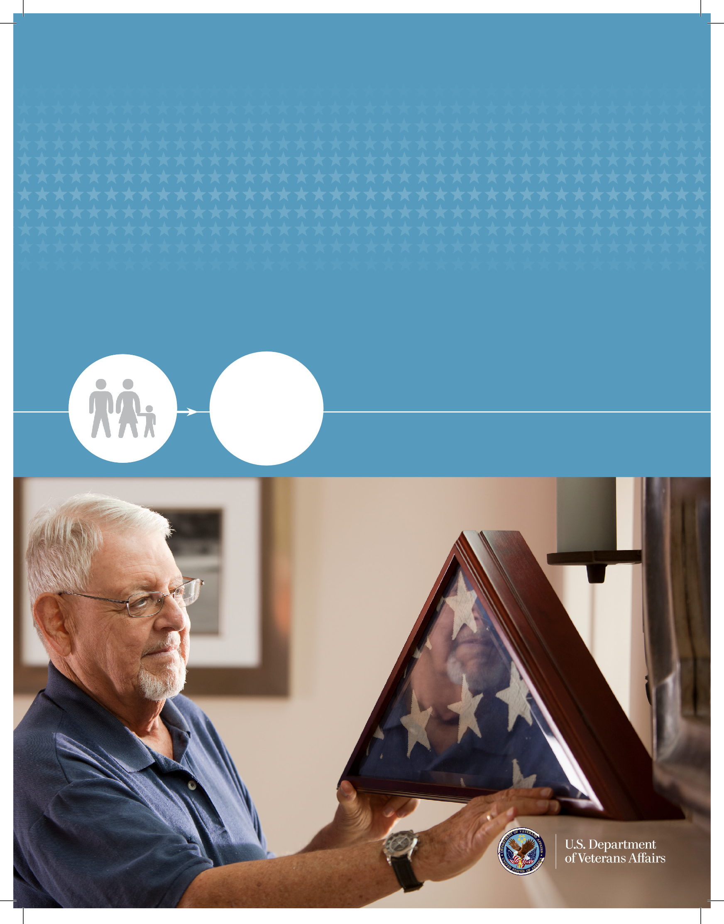

VA supports Servicemembers’ and Veterans’ families
Summary of VA Dependents’ and Survivors’ Benefits

VA honors the sacrifices of Servicemembers’ and Veterans’ dependents and survivors
through many benefit programs, which may be available to a surviving spouse, dependent child(ren), and/or parent(s).
Dependents’ and survivors’ benefit programs include the following:
» Dependency and Indemnity Compensation (DIC) — a monthly tax-free benefit paid to a surviving spouse, including additional payments for dependent children. Parents’ DIC is paid to surviving parents based on financial need
» Survivors’ Pension — a monthly income based tax-free benefit payable to a surviving spouse and/or child(ren) of a deceased Veteran with wartime service
» The Civilian Health and Medical Program of the Department of Veterans Affairs (CHAMPVA) — a benefit that provides reimbursement for most medical expenses to certain surviving spouses
and dependents of Veterans with permanent and total service-connected disabilities who are not eligible for TRICARE
» Dependents’ Educational Assistance Program (DEA) — a benefit that provides assistance
to obtain a degree and pursue other eligible education and training
» Home Loans — a benefit that may be used to help purchase, construct, or improve a home. It may also be used to refinance a mortgage
» Burial — a benefit that includes furnishing a headstone, marker, or medallion, a burial
allowance, a Presidential Memorial Certificate, and an American flag to drape over the deceased’s casket, as well as the option of burial in a VA national cemetery

Access Your VA Benefits
Go to eBenefits at www.ebenefits.va.gov, your one-stop shop to learn about and apply for your benefits.

DEPENDENCY AND INDEMNITY COMPENSATION
Dependency and Indemnity Compensation (DIC) is a monthly tax-free benefit provided to an eligible surviving spouse, dependent child(ren), and/or parent(s) of a deceased Servicemember or Veteran.

You may be eligible for DIC benefits if you are a surviving spouse, dependent child, or parent of a:
» Servicemember who died while on active duty or training, OR
» Veteran who died as a result of a service-related disability, OR
» Veteran who was receiving or entitled to receive VA compensation for a service-connected disability that was rated as totally disabling:
› for at least 10 years immediately preceding death, OR
› since the Veteran’s release from active duty and for at least five years immediately preceding death, OR
› for at least one year immediately preceding death if the Veteran was a former prisoner of war (POW)

Spouse. Your eligibility as a recognized surviving spouse requires that you:
» Were validly married to the Veteran before January 1, 1957, OR
» Were married to the Veteran within 15 years of discharge from the period of military service in which the disease or injury that caused the Veteran’s death began or was aggravated, OR
» Were married to the Veteran for at least one year prior to the Veteran’s death, OR
» Had a child with the Veteran, AND
» Cohabited with the Veteran continuously until the Veteran’s death, AND
» Are not remarried, however, surviving spouses who remarry on or after December 16, 2003, and are 57 or older can continue receiving DIC
DIC provides a basic payment rate plus additional allowances for each dependent child, as well as Aid and Attendance or Housebound benefits.
The Aid and Attendance benefit is paid in addition to your monthly compensation amount under any of the following conditions:
» You require help in performing daily functions, which may include bathing, eating, or dressing
» You are bedridden
» You are in a nursing home
» Your eyesight is limited to a corrected 5/200 visual acuity or less in both eyes

Dependent Children. You may be eligible for DlC benefits if you are not included in your surviving parent’s DIC benefit, are not married, and are younger than 18 or between ages 18 and 23,
if attending school. Certain adult children who become seriously disabled prior to age 18 may also be entitled to DlC.
Parents. Parents’ DIC is an income-based monthly tax-free benefit, and may be available if your child was a Servicemember or Veteran who died from
a service-related cause and you were financially dependent on him or her.

DIC provides a basic payment rate plus additional allowances for each dependent child, as well as Aid and Attendance or Housebound benefits.
The Aid and Attendance benefit is paid in addition to your monthly compensation amount under any of the following conditions stated above.

The Housebound benefit is paid in addition to your monthly DIC amount if a permanent disability substantially prevents you from leaving your immediate dwelling.

You may also be entitled to an additional allowance if you have a dependent child under the age of 18 in your household.

SURVIVORS’ PENSION

Survivors’ Pension is a tax-free needs-based benefit paid to an un-remarried surviving spouse and/or unmarried child(ren) of a deceased wartime Veteran. You must have an income below a yearly limit set by Congress to be eligible for pension benefits.

You may be eligible if you are the surviving spouse or dependent child of a Veteran who:
» Received a discharge from service under conditions other than dishonorable, AND
» Served at least 90 days of active military service with at least one day during a wartime period (the 90-day active service requirement does not apply to Veterans with a service-connected
disability justifying discharge from the military), OR
» Served at least 24 months, or the full period for which the Veteran was called or ordered to
active duty (with some exceptions), with at least one day during a wartime period if the Veteran entered active duty after September 7, 1980

Dependent children may be eligible for Survivors’
Pension if they are permanently incapable of
self-support due to a disability incurred before age 18, are not married, and are younger than 18 or between ages 18 and 23, if attending school.

Surviving spouses may be eligible for Survivors’ Pension if they continuously lived with the Veteran from the date of marriage until the Veteran’s death and have not remarried, with certain exceptions.

THE CIVILIAN HEALTH AND MEDICAL PROGRAM OF THE DEPARTMENT OF VETERANS AFFAIRS (CHAMPVA)
The Civilian Health and Medical Program of the Department of Veterans Affairs (CHAMPVA) shares the cost of most health care services and supplies with unmarried surviving spouses and children who are not eligible for TRICARE. To be eligible, you must be the spouse or child of a Veteran who:
» Is permanently and totally disabled due to a service-connected disability, OR
» Died of a service-connected disability, OR
» Was permanently and totally disabled due to a service-connected disability at the time of death, OR
» Died during active duty (not due to own personal misconduct)

If you remarried after the Veteran’s death and your marriage ended in death, divorce, or annulment, your eligibility for VA benefits may be restored. If you remarried at age 57 or older, or at age 55 or older for CHAMPVA entitlement, you generally retain eligibility to DIC, home loan guaranty, and education training benefits.

EDUCATION AND TRAINING BENEFITS

Dependents’ Educational Assistance (DEA). Dependents’ Educational Assistance (DEA) provides assistance for degree and certificate programs, apprenticeships, correspondence courses, On-the-Job Training (OJT), and other programs. You may be eligible for DEA benefits if you are the spouse or child of a:
» Veteran who died or is permanently and totally disabled as the result of a service-connected disability, OR
» Veteran who died from any cause while a permanent and total service-connected disability existed, OR
» Servicemember who died during active military service, OR
» Servicemember missing in action or captured in the line of duty by a hostile force, OR
» Servicemember forcibly detained or interned in the line of duty by a foreign government or power, OR

The program offers up to 45 months of education benefits. Children generally must use the benefit between the ages of 18 and 26. If you are a spouse, benefits generally end 10 years from
the date VA finds you eligible. If VA rated the Veteran permanently and totally disabled with an effective date of three years from discharge, or if the Servicemember died on active duty, a spouse will be eligible for benefits for 20 years from the effective date of the rating or date of death.
Marine Gunnery Sergeant John David Fry Scholarship. The Marine Gunnery Sergeant John David Fry Scholarship provides children with financial support for tuition and fees, books and supplies, and housing. You may be eligible for up to 36 months of Fry Scholarship benefits if you are the child of a Servicemember who died during active duty after September 10, 2001. You must use your benefits between your 18th and 33rd birthdays.
You may still be eligible if you are married.

You are not eligible for Fry Scholarship benefits if you are serving or have served in the Armed Forces and are eligible for benefits under the Montgomery GI Bill-Active Duty, Montgomery GI Bill-Selected Reserve, and/or the Reserve Educational Assistance Program (REAP), unless you relinquish your eligibility to those benefits. If you are also eligible to receive Dependents’ Educational Assistance Program (DEA) benefits, you may not use both benefit programs at the
same time. You may use up to a total of 48 months of benefits between the two programs.

HOME LOAN GUARANTY

VA-guaranteed loans are provided by private lenders, such as banks and mortgage companies, and not by VA directly.
Certificate of Eligibility. You must present a Certificate of Eligibility (COE) from VA that verifies your spouse’s military service to the lender to qualify for a VA-backed loan. The easiest way
to obtain a COE is through eBenefits at
www.ebenefits.va.gov.

There are many benefits that a VA home loan guaranty can provide. For example:
» VA home loans can be obtained even when you do not qualify for other loans
» VA home loans often have lower interest rates and closing costs than conventional loans
» You may not have to make a down payment or buy mortgage insurance
» There are no fees if you pay off your VA home loan early
» VA Loan Technicians can work with you to explore all options to avoid foreclosure if you are having difficulty making payments

» Servicemember who is hospitalized or receiving outpatient treatment for a permanent and total service-connected disability and is likely to be discharged for that disability

Counseling is available to help dependents determine career goals and how to best use their VA dependents’ education benefits.
For dependents needing special assistance to accommodate a disability prior to or during the pursuit of vocational training, VA can provide assessment and rehabilitation planning to help identify suitable training programs and the resources available to succeed.

VA can also guarantee a portion of a loan made by a private lender, which may be used to:
» Purchase, construct, or improve a home
» Purchase a manufactured home and/or lot
» Refinance your existing mortgage on a home that you personally occupy

You may be eligible for a VA home loan if you have a good credit score and sufficient income, and if you are:
» An unmarried surviving spouse of a Veteran who died of a service-connected disability, OR
» A surviving spouse of a Servicemember or a Veteran who died during active duty or of a service-connected disability, who remarried on or after December 16, 2003 at age 57 or older, OR
» A spouse of a Servicemember officially listed as either missing in action (MIA) or a prisoner of war (POW) for at least 90 days

If you obtained a VA home loan with your spouse prior to his or her death, you may be eligible to obtain a lower interest rate by refinancing your existing VA loan. VA home loan benefits do not expire and may be used anytime.

BURIAL BENEFITS

VA understands that burial and funeral expenses can be a hardship for families of recently deceased Servicemembers and Veterans. VA provides the following burial and memorial benefits:
» Inscribed headstone or marker at any cemetery, or a medallion to affix to one that is privately purchased. Spouses and dependents are eligible for a headstone or marker if they are buried in a national cemetery, state Veterans’ cemetery, or military base cemetery
» Burial allowance to partially reimburse the burial and funeral costs of an eligible Veteran
» Presidential Memorial Certificate (PMC), which is an engraved certificate, signed by the current
president, to honor the memory of an honorably discharged deceased Veteran, provided to the next of kin and loved ones of a deceased Veteran
» American flag to drape the casket of a Veteran

Eligible Veterans, as well as their qualifying spouses, children, and parents, may receive burial in a national cemetery. Go to www.cem.va.gov for more information on eligibility and requirements.

OTHER BENEFITS

There are additional benefits available to you, including:

Educational and Vocational Counseling –
is available to help decide how best to use VA dependents’ educational assistance benefits.
VA can also provide assessment and rehabilitation planning for dependents with disabilities to help identify the resources needed to achieve
a successful outcome.

Beneficiary Financial Counseling Service –
is a personalized service offered to beneficiaries of SGLI and VGLI VA Life Insurance policies that can help you make smart financial decisions.
Services include, but are not limited to, budgeting assistance, debt reduction assistance, and college/ retirement planning.

Bereavement Counseling – is a counseling service available at community-based Vet Centers to parents, spouses, and children of Servicemembers, National Guard members, and Reserve members who die in service.

Civil Service Preference – is a hiring preference for jobs within the Federal government. An unmarried surviving spouse of certain deceased Veterans may also qualify. VA provides an eligibility certification upon request.

Commissary and Exchange Privileges – are provided by the Department of Defense to an un- remarried surviving spouse of a Servicemember or Veteran who died during active duty, or due to a service-connected disability. Dependents are also eligible for privileges. VA provides an eligibility certificate upon request.
Summary of Benefits. The table below provides a broad overview of the eligibility requirements for Dependents’ and Survivors’ benefits. Use this table to determine the benefits that you might qualify for and seek out more information about eligibility criteria, as well as how to apply.

 | Eligibility | Needs-based | Service  Requirement | Veteran died on active  duty | Veteran died as a result  of a service- connected disability | Veteran has a totally  disabling service-  connected disability | Veteran was totally disabled by a service- connected disability  at time of death
DIC | S,C |  |  | ti | ti |  | ti
Parents’ DIC | P | ti |  | ti | ti
Survivors’ Pension | S,C | ti | 90-days, at least one day during a wartime period
CHAMPVA | S,C |  |  | ti | ti | ti | ti
DEA | S,C |  |  | ti | ti | ti | ti
Fry Scholarship | C |  | Service after 9/10/01 | ti
Home Loan | S |  |  | ti | ti
Burial | S,C,P |  |  | ti | ti |  | ti
Key: S=Spouse, C=Child, P=Parent

I CARE
DEPARTMENT OF VETERANS AFFAIRS
VA adopted five core values that define “who we are,” our culture, and how we care for Veterans, their families, and other beneficiaries. The values are Integrity, Commitment, Advocacy, Respect, and Excellence (I-CARE).

Additional VA Benefits
Disabilities determined by VA to be related to your military service can lead to monthly non- taxable compensation, enrollment in the VA health care system, a 10-point hiring preference for federal employment, and other important benefits. Ask your VA representative or Veterans Service Organization (VSO) representative about Disability Compensation, Pension, Health Care, Caregiver Program, Vocational Rehabilitation and Employment Services, Educational Assistance, Home Loan Guaranty, Insurance, and/or Dependents’
and Survivors’ Benefits. You can search for a VSO representative online at www.ebenefits.va.gov.

Thank you for your service. Now let us serve you.

For More Information
For more information about disability compensation benefits, including eligibility, establishing a service-connected disability, and how to apply, please:

» Find links to VA benefits information and apply at www.ebenefits.va.gov
» Visit us at www.va.gov/benefits
» Use IRIS, VA’s tool to find information and ask questions online at https://iris.custhelp.com
» Call us at 1-800-827-1000
» Visit the nearest VA regional office. To find the VA regional office nearest you, go to our website or call VA toll free at 1-800-827-1000

