VA SURVIVOR BENEFITS & THE PACT ACT

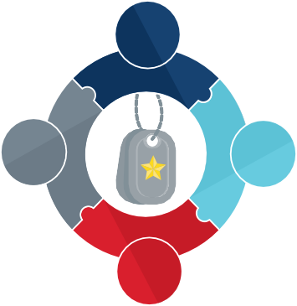
The PACT Act makes it easier for many survivors to receive Dependency and Indemnity Compensation (DIC).
VA will be contacting survivors who were previously denied DIC benefits and may be newly eligible under the PACT Act. You do not need to wait for VA to contact you to submit a claim.

How to Apply for DIC and/or Accrued Benefits
Surviving family members may apply for these benefits using the appropriate VA form on va.gov/family-member-benefits.

Dependency and Indemnity Compensation
Monthly payment for the eligible surviving spouse, dependent children or parent(s) of the Veteran or service member IF Veteran or service member died in the line of duty or due to a service-related injury or illness.

Accrued Benefits
A one-time payment to a surviving spouse, dependent child(ren) or dependent parent(s) of a deceased Veteran based on relationship when the record shows additional benefits (such as VA
compensation or pension) due to the Veteran prior to passing.

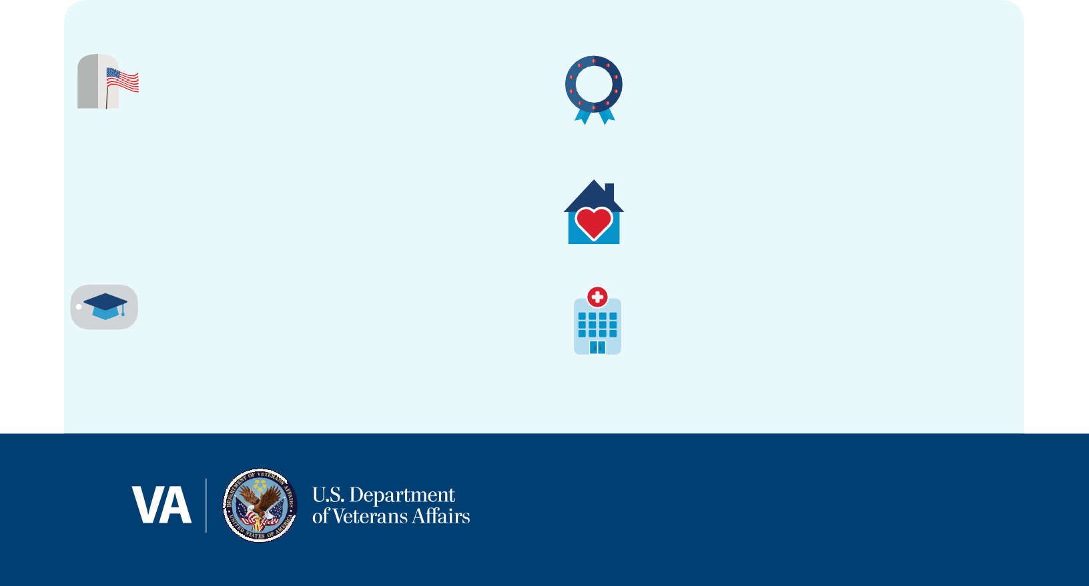
Additional Survivor Benefits Available:

Burials and Burial Allowance
Burial benefits available include a gravesite in any of our National cemeteries with available space, opening and closing of the grave, perpetual care, a government headstone, marker, or medallion, a burial flag, and a Presidential Memorial Certificate, at no cost. Some survivors may also be eligible for a plot allowance, transportation allowance, and burial allowances based on the service connected disability status of the deceased Veteran.

Education and Training
Chapter 35 benefits and Fry Scholarship are the two main GI Bill programs offering educational assistance to survivors and dependents of Veterans who died in the line of duty or as a result of service-related disabilities.

Final Monthly Payment
If a Veteran who is receiving VA compensation or pension benefits passes away, their last month of benefits can be paid to their surviving spouse.

Home Loan Guaranty
Certificate of Eligibility is available for surviving spouses receiving DIC.

Health Care
Survivors and dependents of Veterans may qualify for health care benefits, such as CHAMPVA.

You may be eligible for VA benefits and services after your loved one has passed.

VA SURVIVOR BENEFITS & THE PACT ACT

Learn more and sign up at VA.gov/PACT Download the VA Health and Benefits App Call us at 1-800-MyVA411 (1-800-698-2411)
Find a VA at VA.gov/find-locations/

