Increase Access to VA Health Care and Benefits for Women Veterans with SCI/D
The Issue
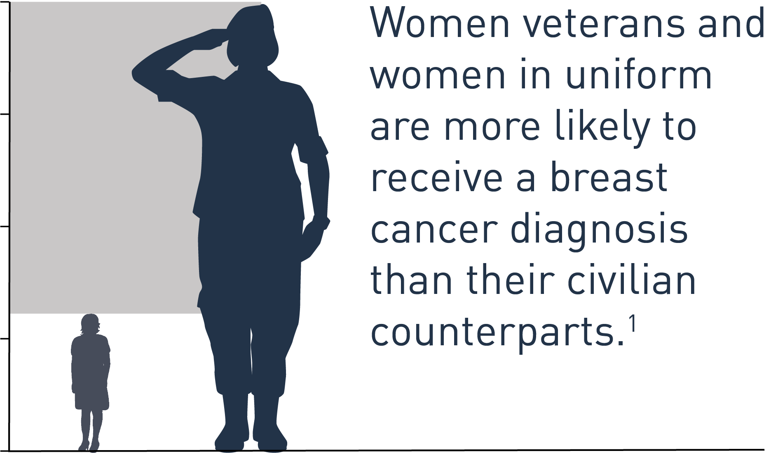
More than three-quarters of a million women veterans are currently using health care through the Department of Veterans Affairs (VA), and this rate is expected to grow. Women veterans with spinal cord injuries and disorders (SCI/D) are a small but significant subset of these users.
Women veterans, including those living with SCI/D, need access to comprehensive, gender-specific mental and physical health care with high standards of care regarding the quality, privacy, safety, and dignity of that care. VA has a robust SCI/D system of care to serve the needs of veterans with SCI/D, but there needs to be an even stronger focus in VA on the needs of women veterans with SCI/D. In addition to having access to SCI/D specific care, these veterans must be able to use other health care services, including those provided through community providers, for other specialty, OB/GYN, emergency, and other types of care. Many of these other services, including breast imaging, are still not fully accessible for wheelchair users.
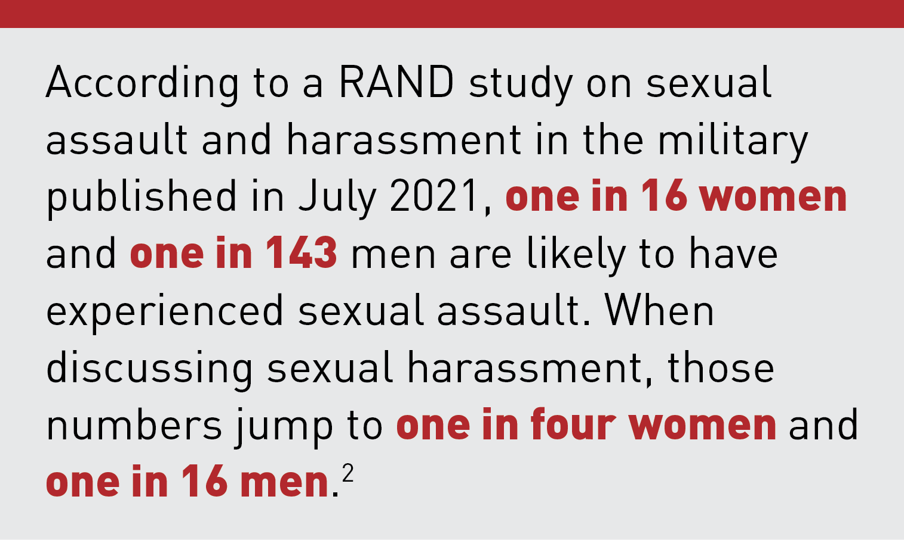
Additionally, VA compensation and pension personnel who process VA benefits claims must be trained to understand the unique and often nuanced needs of women veterans living with SCI/D. For example, PVA members and other veterans with significant disabilities may not experience Military Sexual Trauma (MST) in the same way as other veterans. Compounded traumas may also lead to a higher prevalence of PTSD for many veterans. Because of the lasting psychological and physiological impacts of MST, it is critical that VA train MST coordinators and VA rating officials to the sensitive nature of these claims as well as the range of issues and symptoms experienced with MST, especially for veterans with complex injuries and illnesses.

1. McDaniel, Justin T.; Diehr, Aaron J.; Davis, Cataria; Kil, Namyun; and Thomas, Kate. H. Breast cancer screening and outcomes: an ecological study of county-level female Veteran population density and social vulnerability, 2018 Journal of Military, Veterans and Family Health.
2. Acosta, Joie D., Matthew Chinman, and Amy L. Shearer, Countering Sexual Assault and Sexual Harassment in the U.S. Military: Lessons from RAND Research. Santa Monica, CA: RAND Corporation, 2021.

PVA 2022 Legislative Priorities

PVA POSITION
- VA must ensure women veterans living with SCI/D have equitable access to comprehensive, gender-specific mental and physical health care.
- VA must timely implement the Making Advances in Mammography and Medical Options for Veterans (MAMMO) Act (Public Law 117-135) which was signed into law in June 2022. This law will improve access to breast imaging services for veterans. It also requires VA to issue a report on the accessibility of these services within VA for paralyzed veterans and veterans with other mobility limitations and ensure community care providers have accessible screening services and are provided with best practices.
- VA must ensure benefits personnel receive specialized training to understand the complex needs of women with SCI/D.
- Congress must pass the Servicemembers and Veterans Empowerment and Support Act (H.R. 5666/S. 3025) to ensure that all MST survivors receive appropriate support through the claims process as well as mental health services.

