Improve VA Health Care Services and Benefits for Catastrophically Disabled Veterans and their Survivors: Survivor Benefits
The Issue
Veterans’ survivors may be eligible for certain benefits and services through the Department of Veterans Affairs (VA), but improvements are needed for those left behind to assist them in rebuilding their lives.
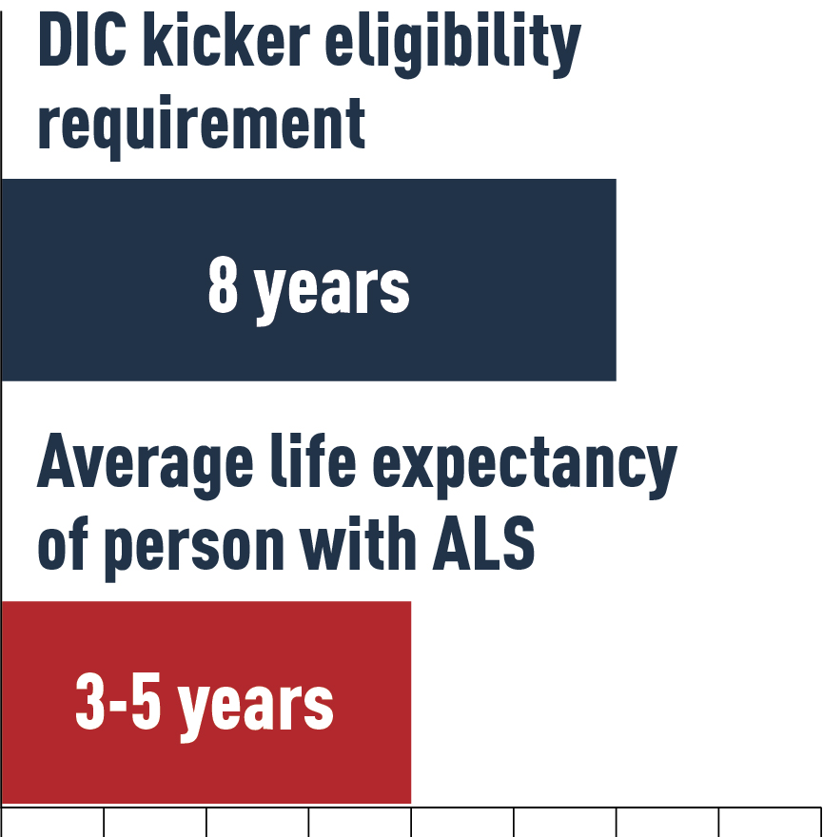
Dependency and Indemnity Compensation (DIC) provides a financial benefit to survivors of veterans who died from a service-connected disability or who died due to a non-service-connected disability but were able to receive VA disability compensation for a service-connected disability rated as totally disabling for a certain period of time. Survivors of service members who died on active duty may also be eligible. Since DIC was established nearly 30 years ago, there have been minimal benefit increases. As a result, rates have failed to keep up with the cost of living and fallen short of what other federal employees’ survivors receive. In addition, many veterans pass away from non-service-connected conditions prior to meeting the DIC eligibility period, which leaves their families with nothing.
Eligible survivors can also receive an additional $305.28 per month in DIC in cases where a veteran who, at the time of death, was in receipt of or was entitled to receive compensation for a service-connected disability that was rated totally disabling for a continuous period of at least eight years. This extra payment is commonly referred to as the “DIC kicker.” Many veterans with ALS are unable to meet the eight-year DIC kicker requirement because the average life expectancy for a person with ALS is three to five years. Thus, their survivors rarely qualify for the additional DIC benefit.

PVA POSITION
- Congress should pass the Justice for ALS Veterans Act (H.R. 5607 /S. 3483) to entitle survivors of veterans who died of service-connected ALS to the DIC kicker.
- Congress should pass the Caring for Survivors Act of 2021 (H.R. 3402/S. 976), which would allow additional survivors to receive DIC benefits and increase the monthly benefit amount to match benefits provided by other federal survivor programs.

