Strengthen and Enhance Social Security Benefits
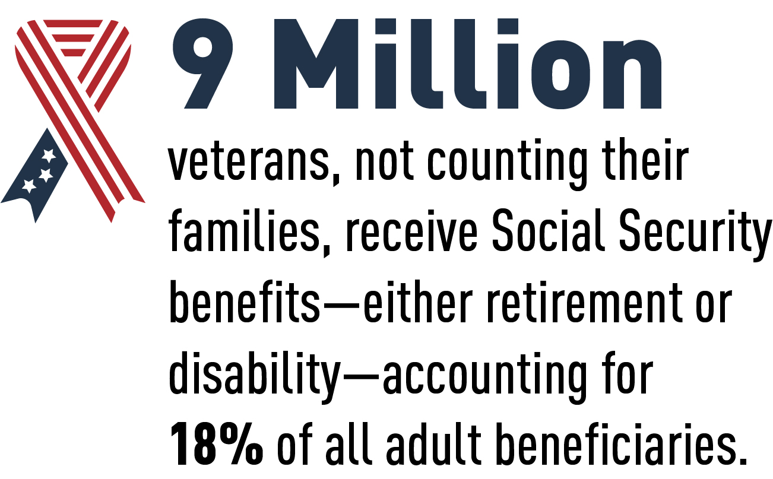
The Issue
More than nine million veterans and their families receive retirement, disability, or survivor benefits from Social Security and, together, they comprise approximately 35 percent of the Social Security beneficiary population. Due to the recession caused by COVID-19, the Social Security trust funds will face a shortfall and be unable to pay full benefits a year earlier than previously anticipated, in 2034. If action is taken now, the current modest shortfall in long-term system funding can be addressed without damaging cuts to beneficiaries. This should be done through prudent, phased-in changes to the system’s financing along with benefit enhancements that will respond to the nation’s growing retirement crisis. Failure to act will mean that, once the trust funds are depleted, there will only be enough incoming revenue from payroll contributions to pay roughly 75 percent of all retirement, disability, and survivor benefits.
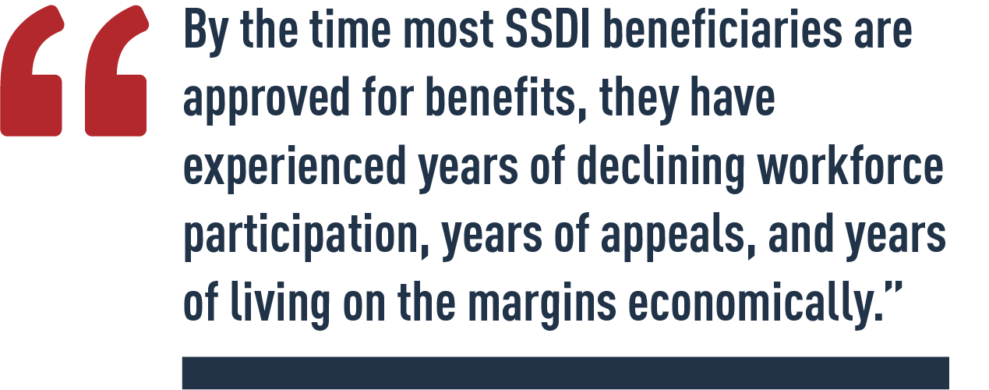
We support setting a more realistic cost-of-living-adjustment (COLA) for Social Security benefits that reflects the types of expenses frequently incurred by retirees and people with disabilities; reducing the tax burden on beneficiaries; ensuring no one retires into poverty by improving minimum benefits; and making long overdue adjustments in the financing mechanisms for the system. We also support gradually eliminating the earnings cliff in Social Security Disability Insurance (SSDI) and making other improvements to the Social Security Ticket to Work Program to remove barriers to work for disability beneficiaries. In addition, we believe it is time to eliminate the five-month waiting period not only for SSDI but also the two-year waiting period for Medicare. We further support helping people understand better the benefits to which they are entitled and protecting them from fraudulent misuse of their Social Security identification number.
From PVA’s December 2021 House Ways and Means, Social Security Subcommittee written testimony. View the testimony.

PVA 2022 Legislative Priorities

PVA POSITION
- Congress must pass the Social Security 2100: A Sacred Trust Act (H.R. 5723/S. 3071), which would accomplish many of the benefit improvements that PVA supports. This legislation includes provisions that would:
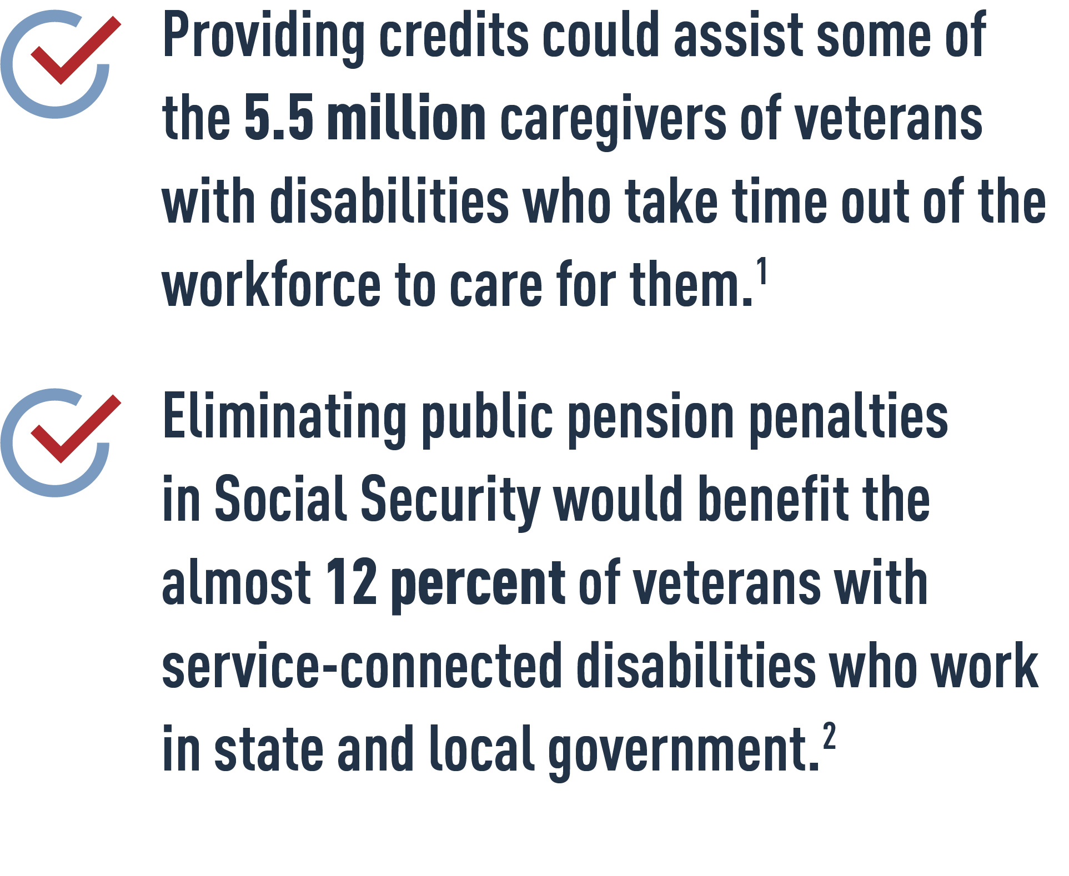
  - Base COLAs on the Consumer Price Index for the Elderly (CPI-E).
  - End the five-month wait for SSDI once someone is determined eligible.
  - Eliminate the SSDI “cash cliff” that hinders the ability of beneficiaries to return to work.
  - Repeal the Windfall Elimination Provision and Government Pension Offset that currently penalize many public servants, including many disabled veterans.
  - Provide credits under Social Security to ensure that caregivers are not penalized in retirement for taking time out of the workforce to care for children or other dependents.

1. Ramchand, Rajeev, Terri Tanielian, Michael P. Fisher, Christine Anne Vaughan, Thomas E. Trail, Caroline Batka, Phoenix Voorhies, Michael W. Robbins, Eric Robinson, and Bonnie Ghosh-Dastidar, Hidden Heroes: America's Military Caregivers. Santa Monica, CA: RAND Corporation, 2014.
2. U.S. Bureau of Labor Statistics. (Mar. 18, 2021). “Employment Situation of Veterans, Table 8.”

