Improve VA Health Care Services and Benefits for Catastrophically Disabled Veterans and their Survivors: Home Modification Grants
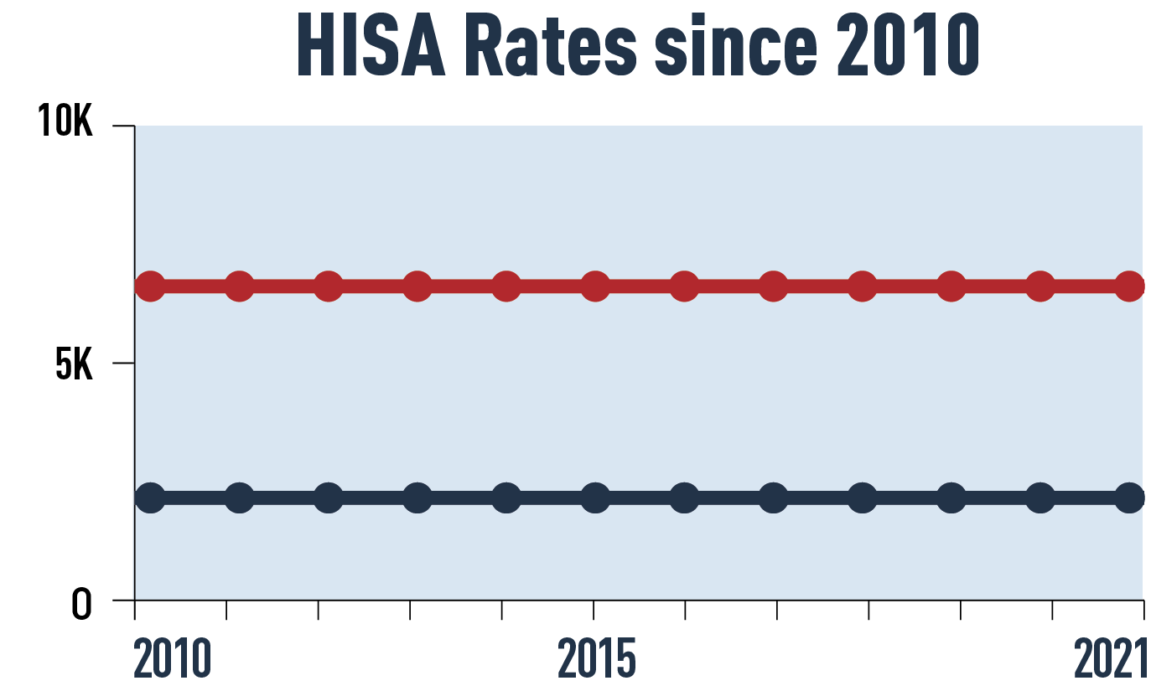
The Issue
The Department of Veterans Affairs’ (VA) Home Improvements and Structural Alterations (HISA) grant program helps veterans and service members make medically necessary improvements and structural alterations to their primary residence.
As the name suggests, the HISA grant helps fund improvements and changes to an eligible veteran’s home. Examples of qualifying improvements include improving the entrance or exit from their homes, restoring access to the kitchen or essential lavatory and sanitary facilities (e.g., lowering counters/sinks), and making necessary repairs or upgrades to plumbing or electrical systems due to installation of home medical equipment. It does not pay for walkways to exterior buildings; spas, hot tubs, or Jacuzzis; exterior decking; or new construction.
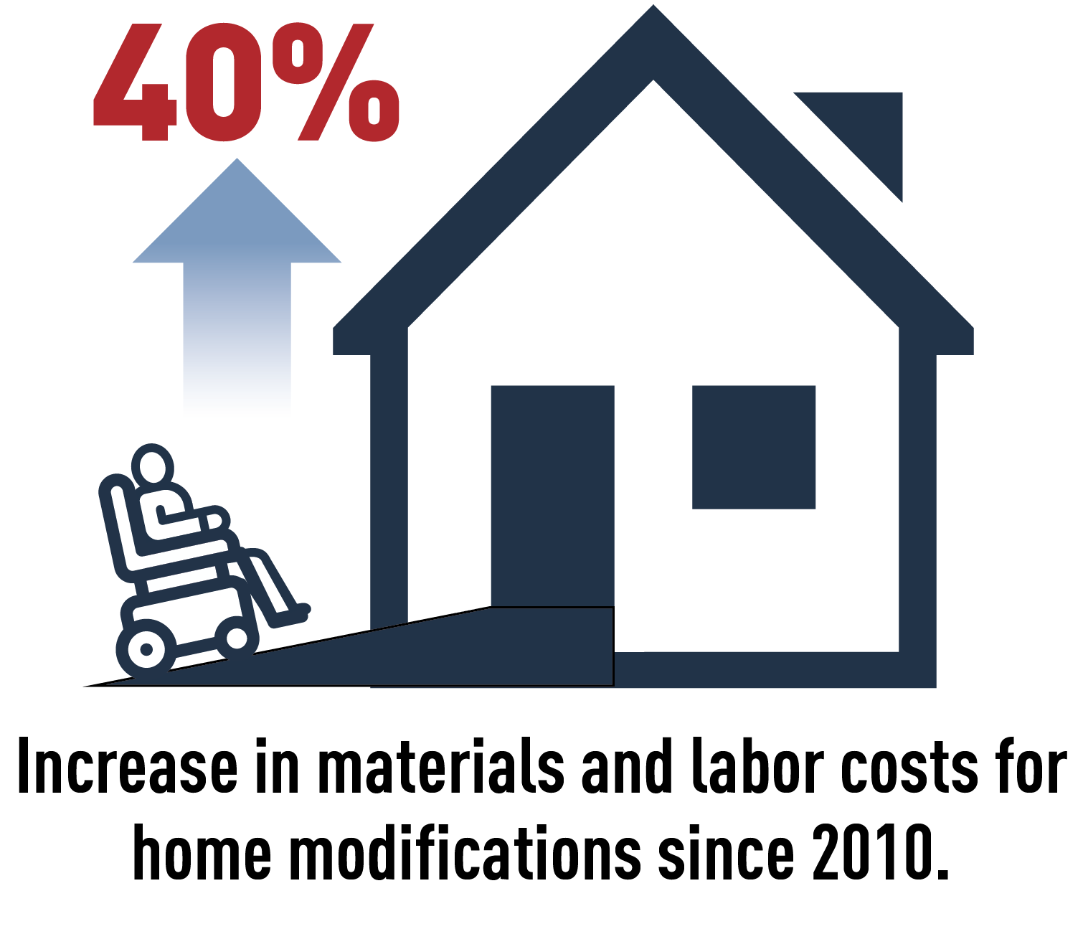
Veterans who need a housing modification due to a service-connected disability may receive up to $6,800. Veterans who rate 50 percent service-connected may receive the same amount even if a modification is needed due to a non-service-connected disability. Veterans who are not service-connected but are enrolled in the VA health care system can receive up to $2,000. These are the maximum amounts an eligible veteran can receive in their lifetime.
HISA rates have not changed since Congress last adjusted them in 2010. Meanwhile, the cost of home modifications and labor has risen more than 40 percent during the same timeframe.

PVA POSITION
- Congress should support and pass the Autonomy for Disabled Veterans Act (H.R. 5819/S. 4721), which would increase HISA grant rates to $10,000 for veterans with a service-connected disability and $5,000 for veterans with a non-service-connected disability and apply an inflation formula to keep them relevant in future years.

