Increase Employment Prospects for Veterans with Disabilities
The Issue
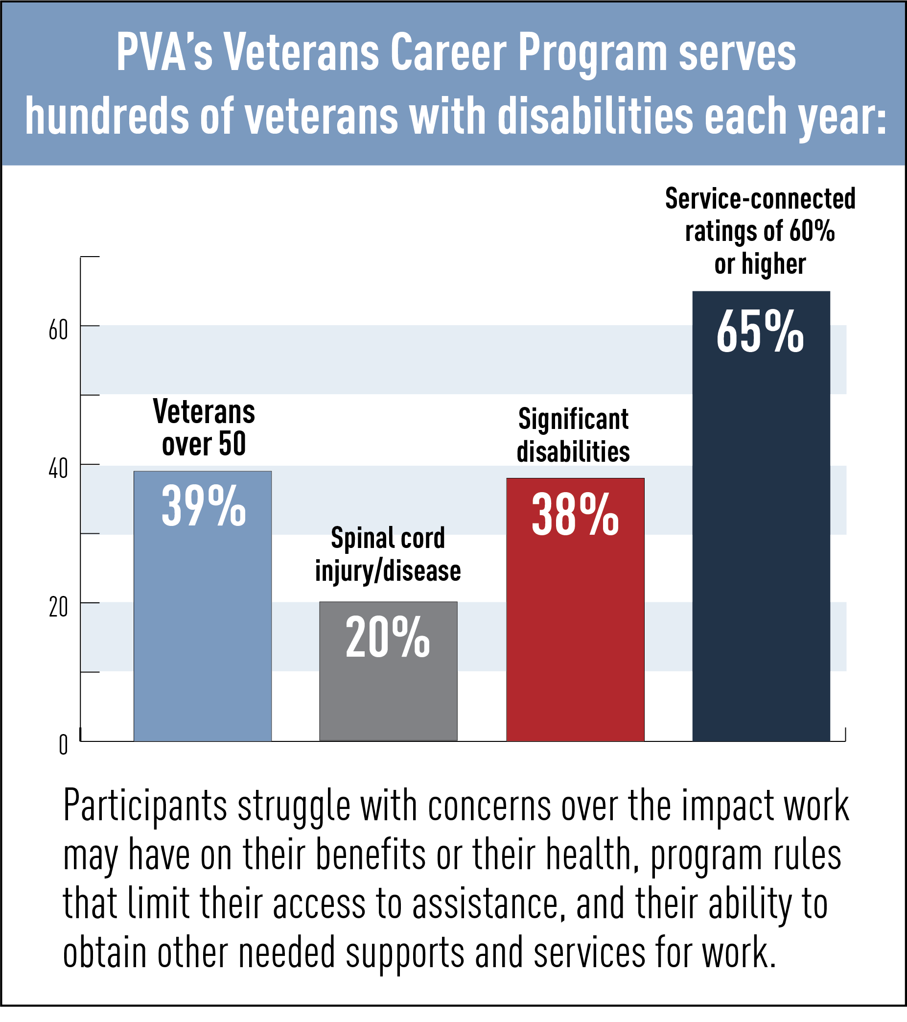
Despite employment protections provided under the Americans with Disabilities Act and other disability rights laws and the modest cost of most job accommodations, the workforce participation rate of people with significant disabilities remains well below the workforce participation rate of people without disabilities. Although the most recent Bureau of Labor Statistics data indicated that the labor force participation rate for veterans with a service-connected disability was not statistically different from the rate for veterans with no disability, that is not the case for veterans with significant disabilities. Unfortunately, little current data even exists about the workforce participation rate of veterans with significant non-service-connected disabilities.
Many disabled veterans rely on employment programs and systems beyond the Department of Veterans Affairs (VA) that are available to assist the broader community of people with disabilities. Tax incentives for employers to hire these populations need to be enhanced and work disincentives in Social Security disability programs need to be addressed. Initiatives to expand disability inclusion in federal employment and contracting are important steps but ongoing oversight is essential. In addition, state workforce systems need to be held accountable for the performance of their services to veterans and people with disabilities.
Veterans with service-connected disabilities may also be eligible to receive employment training and education through VA’s Veteran Readiness and Employment (VR&E) program. Although this program provides critical support for veterans, its performance bears closer examination. Veterans with catastrophic disabilities are too often told that they are unemployable due to their disability. As a result, we are concerned that some catastrophically disabled veterans are being unjustly denied access to this program.

PVA 2022 Legislative Priorities

PVA POSITION
- PVA supports the Disability Employment Incentive Act (H.R. 3765/S. 630), which would enhance the current Work Opportunity Tax Credit available to employers by raising the amount of salary eligible for the credit and the maximum available tax credit, as well as extending the availability of the credit for any business that retains an employee for a second year of employment and allowing use of the credit for hiring SSDI beneficiaries.
- PVA supports the Social Security 2100: A Sacred Trust Act (H.R. 5723/S. 3071), which would replace the “cash cliff” – a major work disincentive – in Social Security Disability Insurance (SSDI) with a gradual reduction in benefits as earned income rises.
- PVA believes the recently released Government-wide Strategic Plan to Advance Diversity, Equity, Inclusion and Accessibility in the Federal Workforce offers important steps for ensuring that the federal government fully embraces people with disabilities in its efforts to become a model employer for the nation. Federal agencies must be transparent and accountable in implementing this plan which arose from Executive Order 14035.
- Congress must provide oversight of the Workforce Innovation and Opportunity Act (WIOA) to ensure that veterans and other people with disabilities are served effectively under WIOA workforce programs.
- Congress must increase oversight and transparency of VA’s VR&E program to improve its effectiveness and ensure catastrophically disabled veterans are not unjustly denied access into this program.

