Protect the Civil Rights of People with Disabilities
The Issue
Congress must make systemic changes to improve air travel for people with disabilities, particularly wheelchairs users, by reforming the Air Carrier Access Act (ACAA) to add standards for aircraft accessibility and strengthen enforcement of the law.
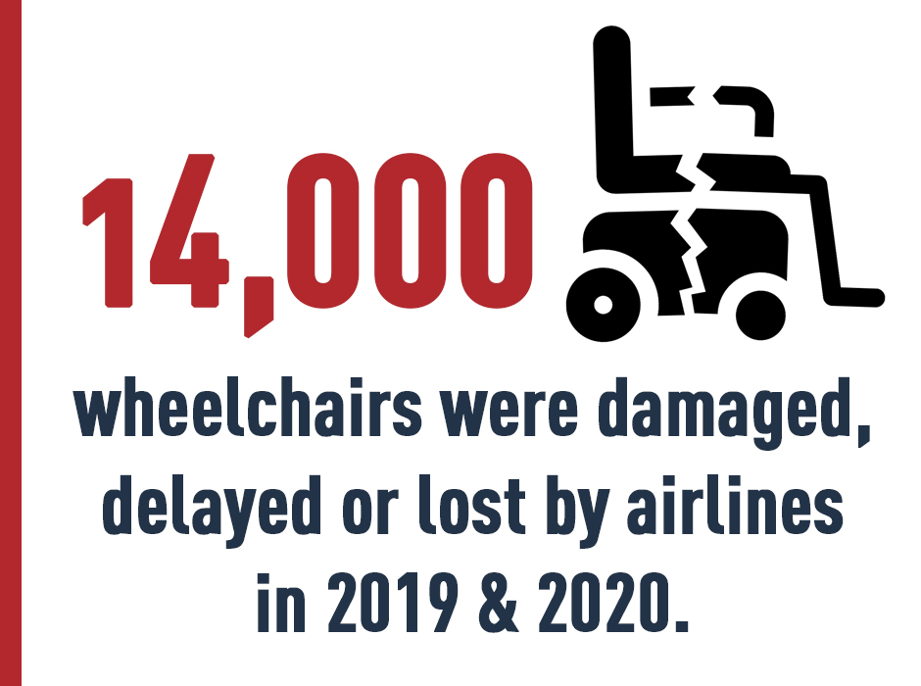
PVA members routinely report incurring bodily harm in boarding and deplaning aircraft, and damage to personal wheelchairs, particularly power wheelchairs, during stowage. The only recourse a passenger with a disability has when faced with ACAA violations is to complain to the airline and the U.S. Department of Transportation (DOT). Unlike most other civil rights laws, the ACAA lacks a guaranteed private right of action. DOT investigates these complaints and, if substantiated, will acknowledge the violation but rarely takes any substantive action against the airline.
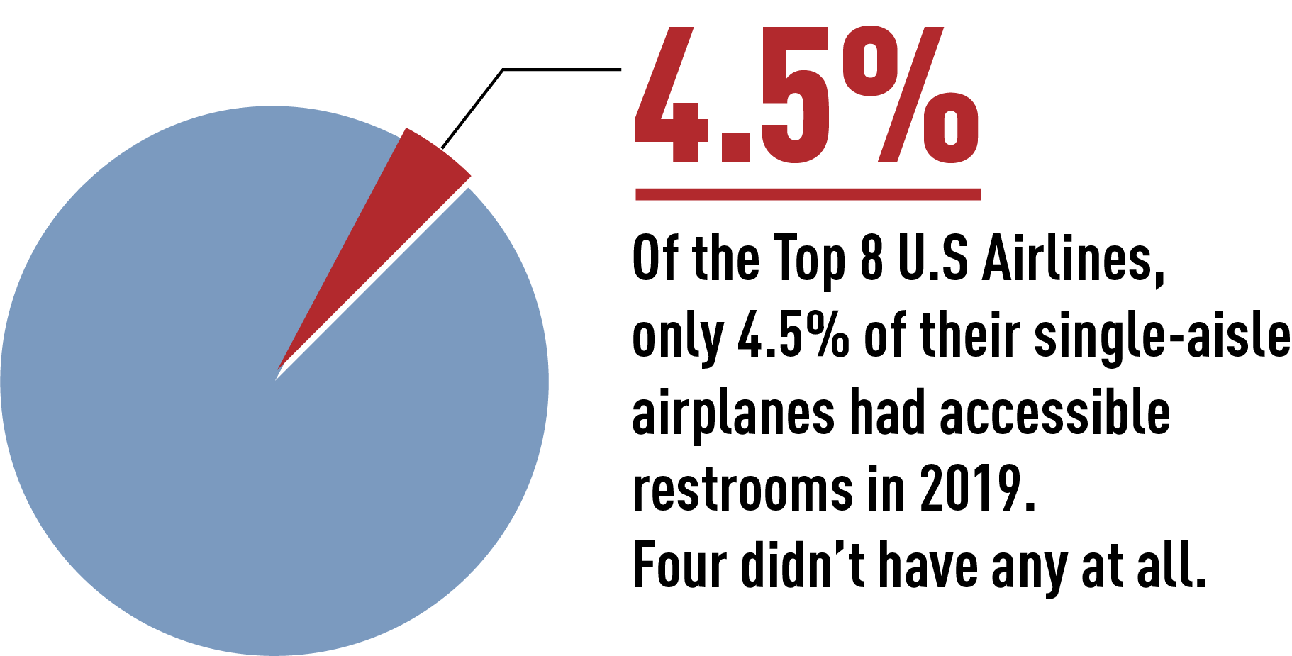
Many of the difficulties that travelers with disabilities encounter in air travel are because the ACAA and its implementing regulations do not provide for safe, dignified access. Specifically, the ACAA does not require aircraft to provide even basic accessibility for passengers with disabilities, particularly those who use wheelchairs. As a result, they often have no access to lavatories on single-aisle aircraft, no accessible path of travel on the aircraft, and wheelchairs are loaded into aircraft cargo pits not designed to fit these highly complex assistive devices. Other modes of public transportation are covered by the Americans with Disabilities Act, which requires compliance with standards that accommodate passengers with disabilities.

PVA POSITION
- PVA urges the passage of the Air Carrier Access Amendments Act (H.R. 1696/S. 642), which would require stricter standards for accessibility on new and existing aircraft and better enforcement of
the law.

