Improve VA Health Care Services and Benefits for Catastrophically Disabled Veterans and their Survivors: Adapted Automobile Benefits
The Issue
VA Automobile Allowance Grants
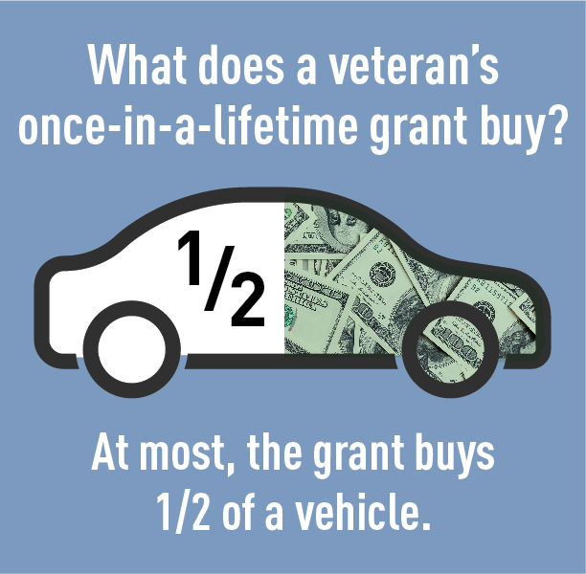
Access to an adapted vehicle is essential to the mobility and health of catastrophically disabled veterans. Autonomy and transportation reliability are equally as critical. Given the high costs of adapted vehicles and lack of public transit in rural areas, many veterans with spinal cord injuries and disorders (SCI/D) are prohibited from securing safe and reliable transportation. Additionally, with air travel being very difficult for many SCI/D veterans, vehicles are the primary mode of transportation and are often driven beyond what would be considered safe due to the high cost of purchasing a new one.
The current, one-time Department of Veterans Affairs’ (VA) Automobile Allowance Grant of roughly $22,300 covers anywhere from one-half to one-third of the cost to procure a vehicle to accommodate certain disabilities that resulted from a condition incurred or aggravated during active military service. The substantial costs of modified vehicles, coupled with inflation, present a financial hardship for many disabled veterans who need to replace their primary mode of transportation once it reaches the end its lifespan.
Automobile Adaptive Equipment
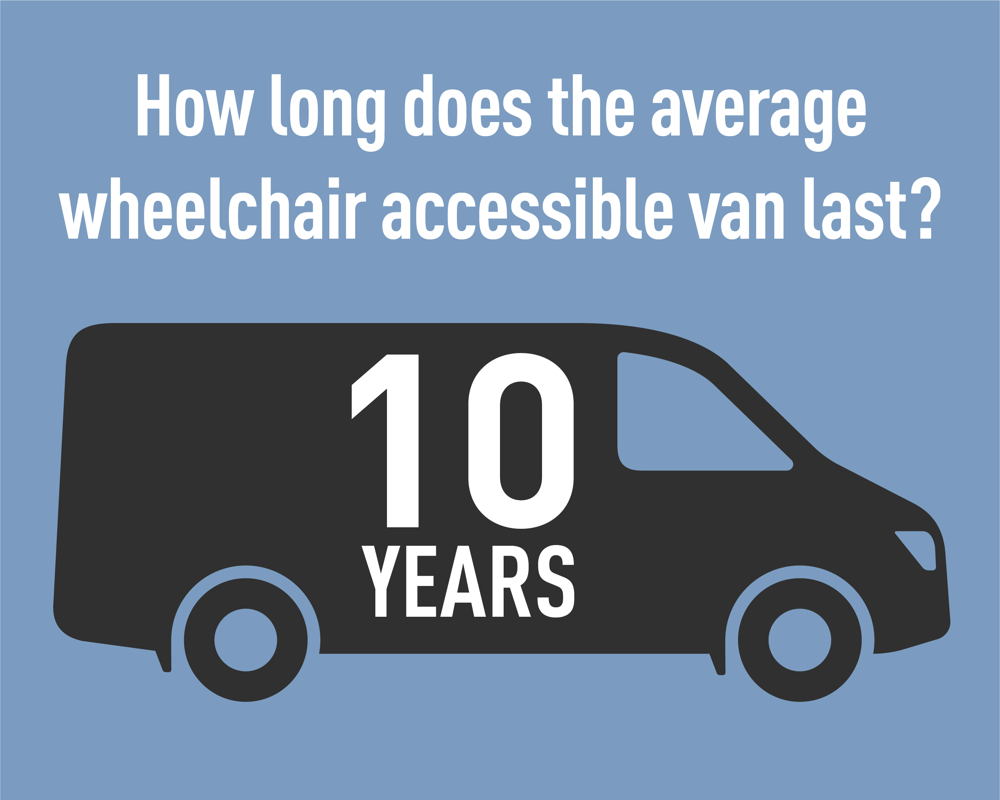
VA’s Automobile Adaptive Equipment (AAE) program helps physically disabled veterans enter, exit, and operate a motor vehicle or other conveyance. VA provides the necessary equipment for veterans with service-connected disabilities, such as platform wheelchair lifts, under vehicle lifts (UVLs), power door openers, lowered floors, raised roofs, raised doors, hand controls, left foot gas pedals, reduced effort and zero effort steering and braking, and digital driving systems.
The program also provides reimbursements (to service-connected veterans) for standard equipment including, but not limited to, power steering, power brakes, power windows, power seats, and other special equipment necessary for the safe operation of an approved vehicle. Support for veterans with non-service-connected disabilities is limited to assistance with ingress/egress only. Catastrophically disabled veterans need the independence AAE provides to transport themselves to and from work, medical appointments, and other obligations.

PVA 2022 Legislative Priorities

PVA POSITION
- PVA supports the AUTO for Veterans Act (H.R. 1361/S. 444), which would allow eligible veterans to receive an Automobile Allowance Grant every ten years to purchase an adapted vehicle.
- PVA supports the CARS for Vets Act (H.R. 3304), which in addition to allowing eligible veterans to receive an Automobile Allowance Grant every ten years to purchase an adapted vehicle, would codify the provision of certain vehicle modifications for qualified veterans with non-service-connected disabilities.
- Congress must direct VA to reimburse the cost of items on the current AAE list and modern driver assistance technologies so veterans with catastrophic disabilities can drive more comfortably and safely.
- Congress must pass legislation that allows veterans who have non-service-connected catastrophic disabilities to receive the same type of adaptive automobile equipment as veterans whose disabilities are service connected.

